TASK 1

Step 2: 2.1-2.9 results

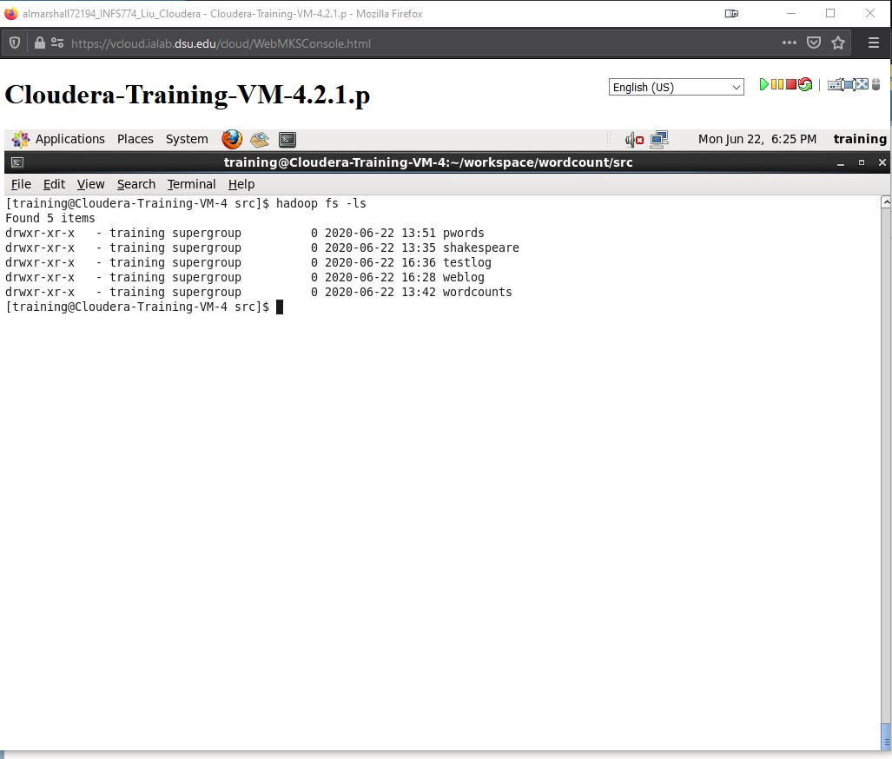



Step 3: Step 3 results

TASK 2

Step 5

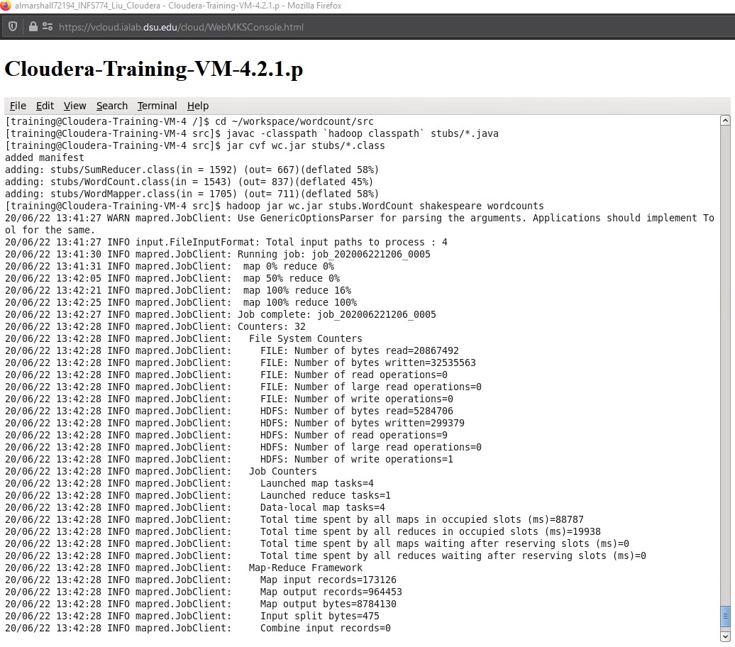

Step 7

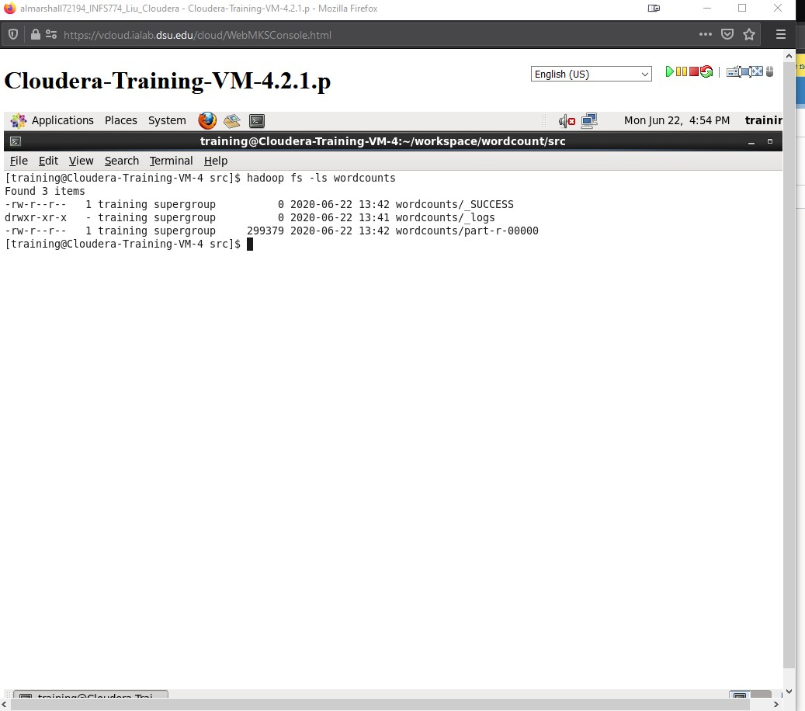

Step 8

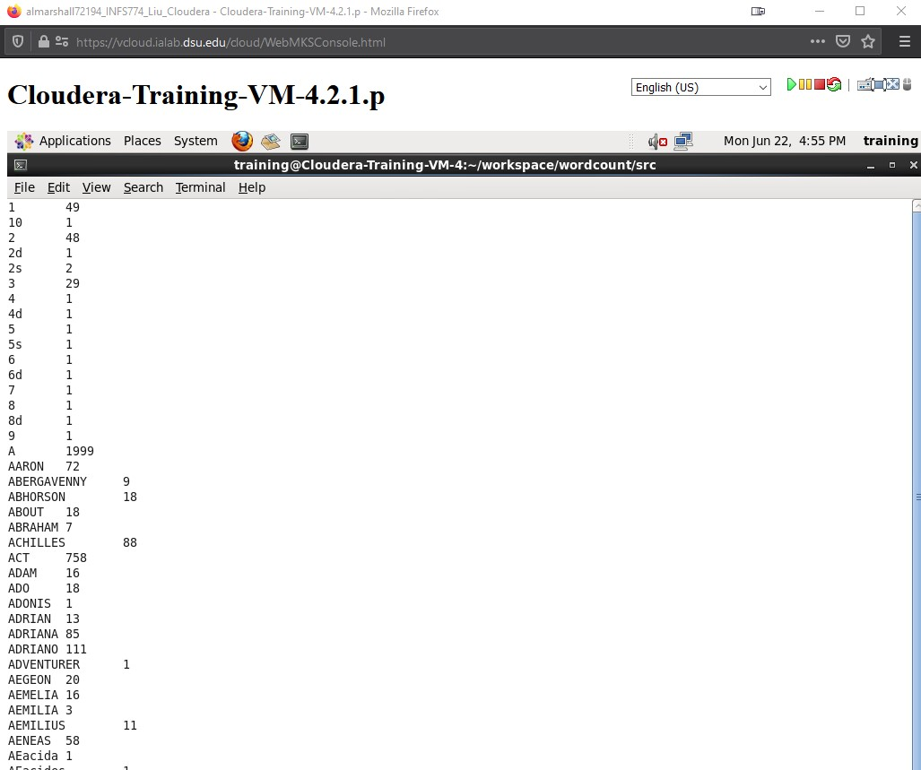

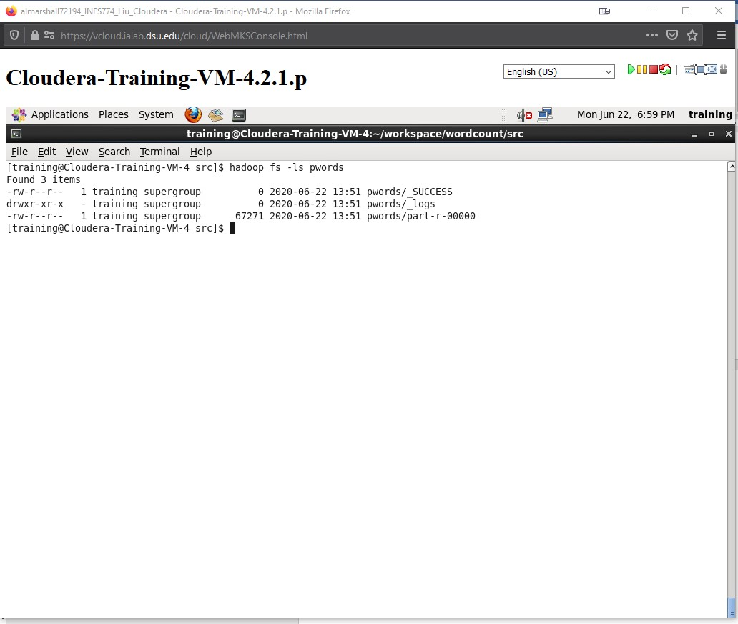

Step 9

TASK 3:

Based on what I read, I see “Big Data Analytics” as a method of processing the same data as other types of Analytics with the primary difference being the data is processed differently based on a few key factors. One of the first factors is that some data cannot be processed using the usual data processes since most of it tends to be unstructured or structured, but raw. Another factor is related to three characteristics attributed to Big Data: volume, velocity, and variety. Volume deals with the sheer amount of data being worked with, while velocity deals with how fast the data is received and stored, and finally variety refers to the different types of data being collected and processed. Yet another factor to consider is that that using Big Data solutions are also viable when not just a sample of the data, but the entire dataset. Also, sometimes, there are no apparent measures for the data that is going to be processed and analyzed, so that is where Big Data comes into play. At the end of the day, Big Data Analytics is ideal for tasks and processed that cannot be done using the traditional relational databases or its tools. To that end, Big Data has at least 2 of its own helpful tools: Hadoop and MapReduce.